**Accessing the Website：**

To run the homework assignment, unzip the folder and open the a2.sln file in Visual Studio. Before running, you need to configure the database connection string in the Web.config file. You can use the test data seeds provided in the file to populate the database with test data.

**Website Layout**:

The layout of this website is mainly composed of **the** **log in page,the regist page, the home page, the destinations page,** and **the tips page**. The Home page, the Destinations page, and the tips page all consist of a navigation bar, body, footer, and a virtual email link and HTML5 and css3 links at the bottom.

**The** **log in page and the regist page.**First of all, you can see a login screen, if you are a new user, click on the "Register" button at the bottom of the homepage, after entering the registration page, you can create an account. If you have already registered an account, you can enter your existing account and click "Log In", which ensures your privacy and account security.

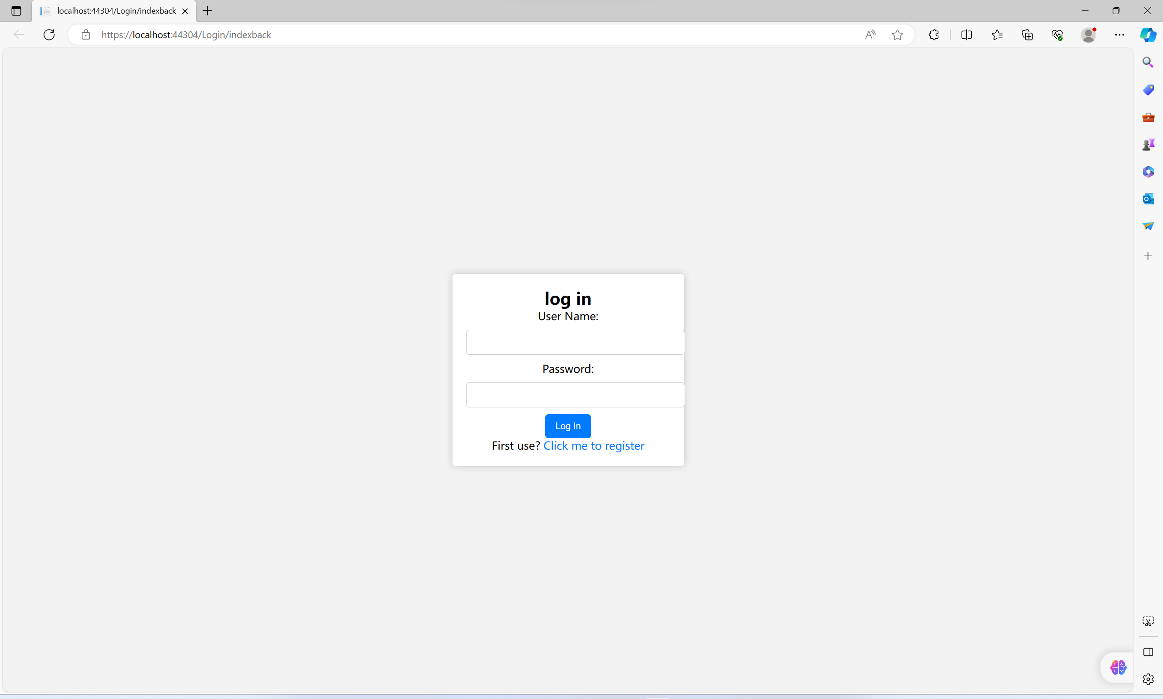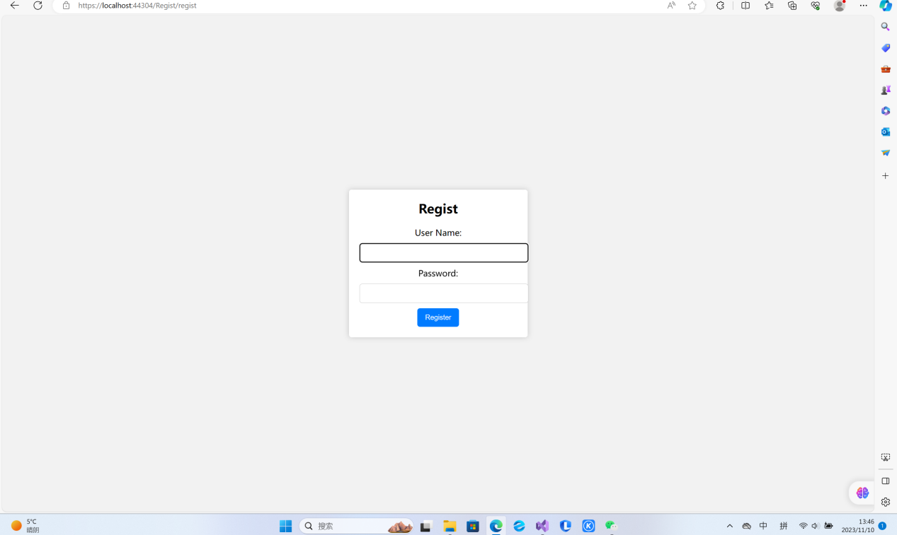

**The home page**, which is mainly used to attract users, can give users a first understanding of the website, and there are two tourist attractions below, Big Ben and the River Thames in London, and the view overlooking the Eiffel Tower, users can click "Read More" to learn more about it.

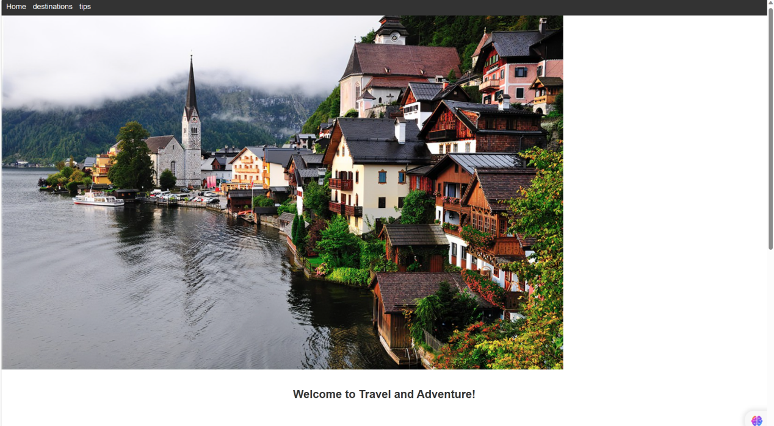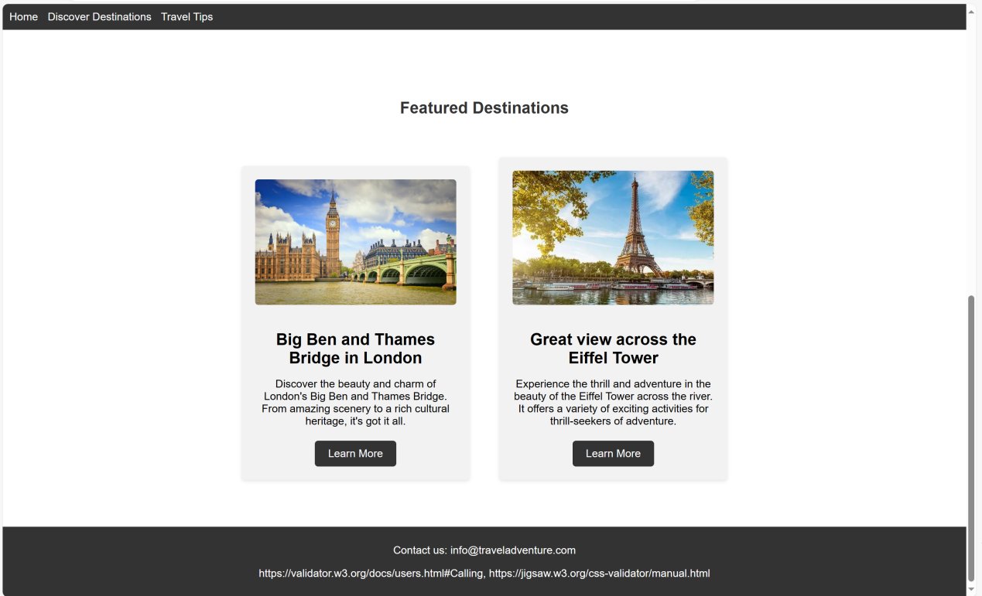There are three pages on **the destinations page**, the first page is a short introduction to Big Ben and the River Thames and the Leaning Tower of Pisa, the second page is a short introduction to the Eiffel Tower and Copenhall, and the third page is a short introduction to Neuschwanstein Castle and St. Andrew's Cathedral in Germany.The page uses the function of pagination and search, and at the bottom of the page there is a search bar that allows you to quickly go to the page you want to visit, and the interface helps users to understand different attractions.

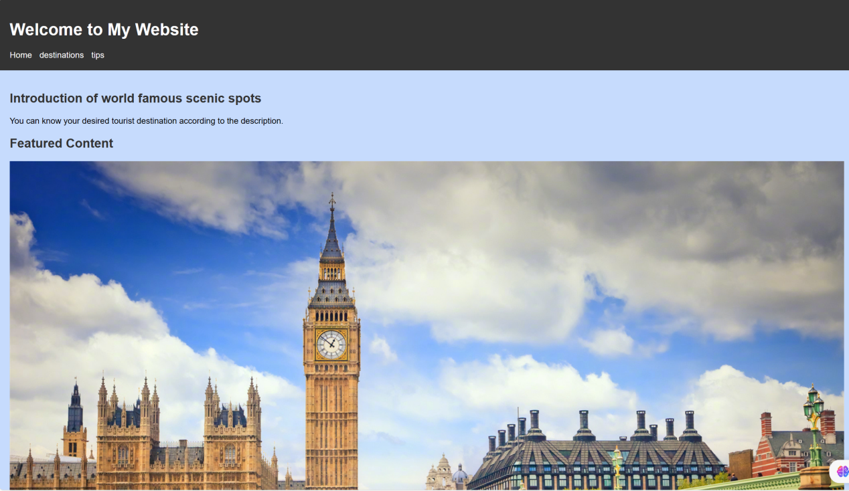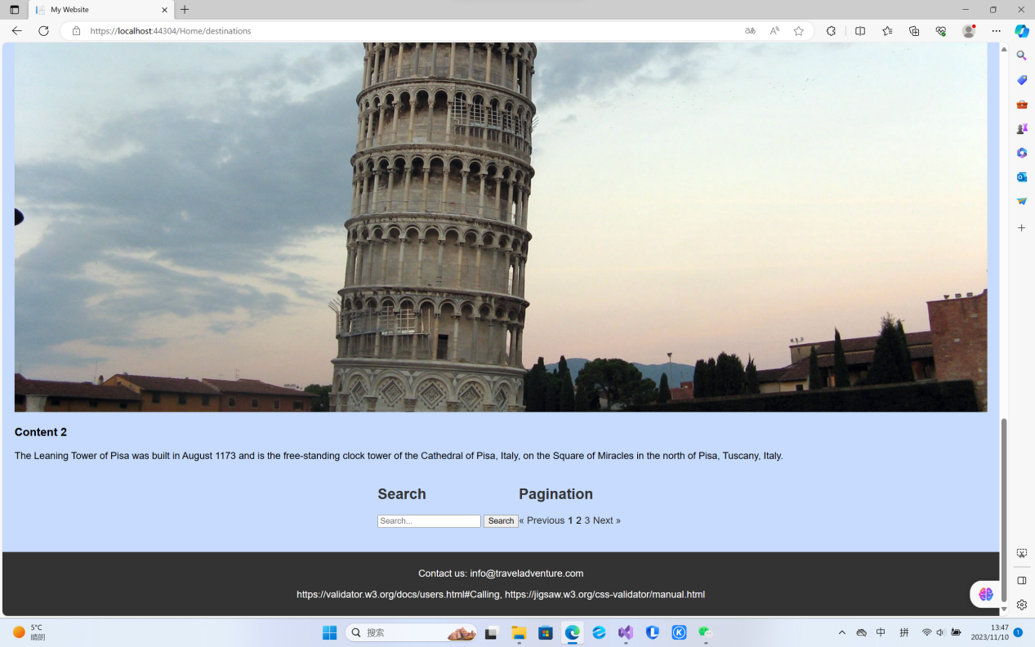

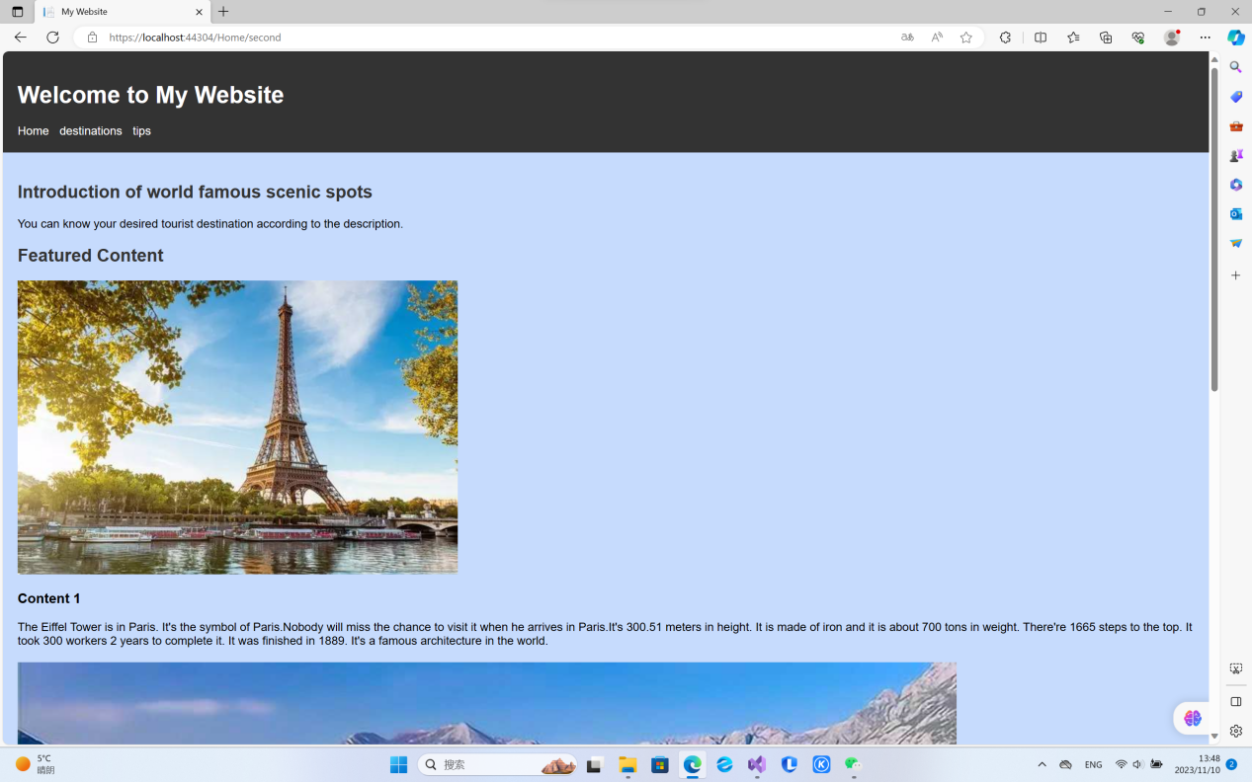

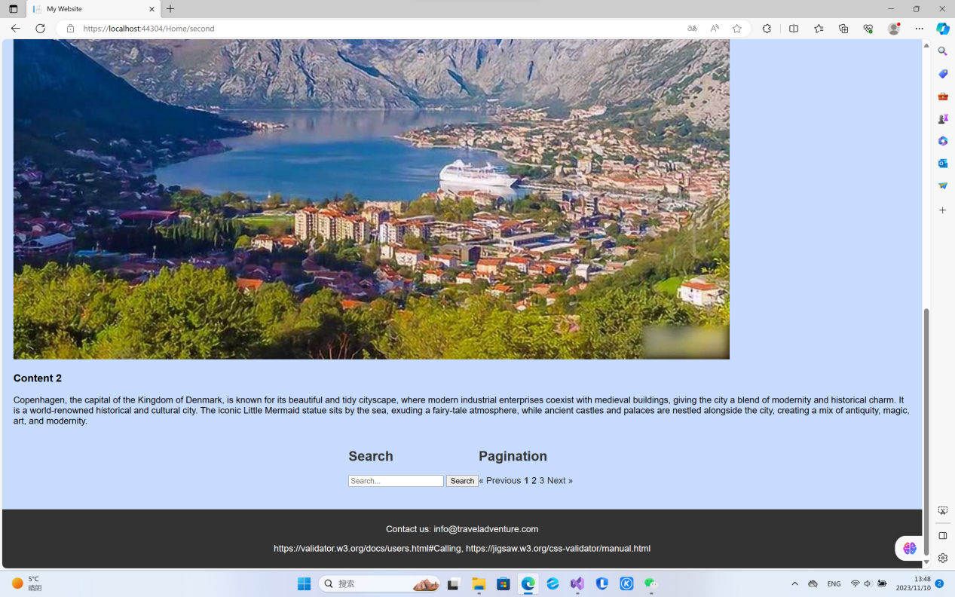

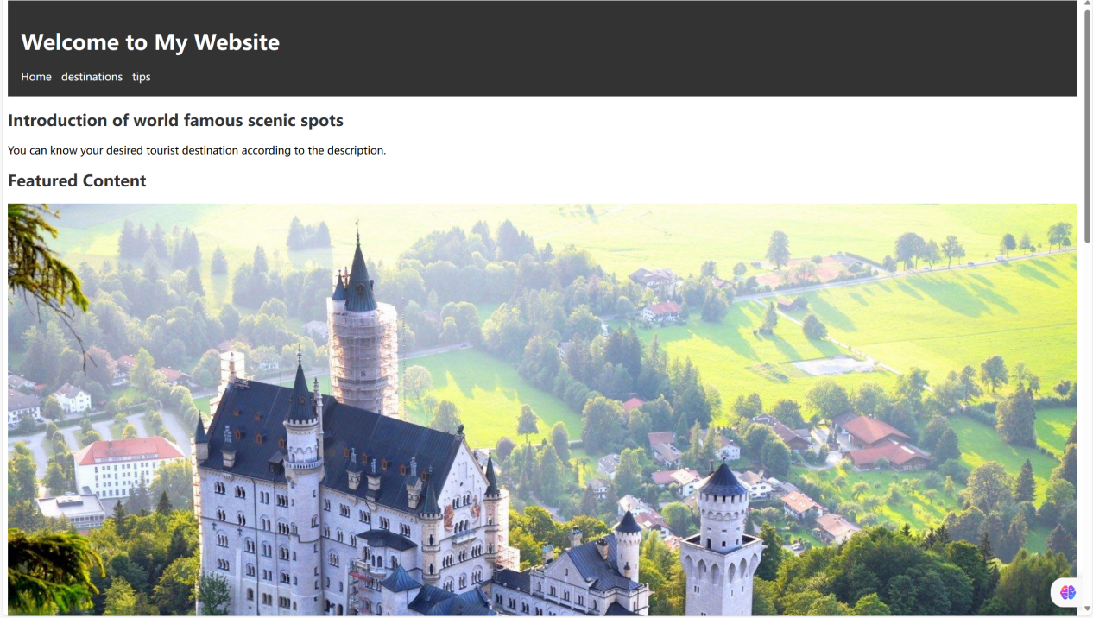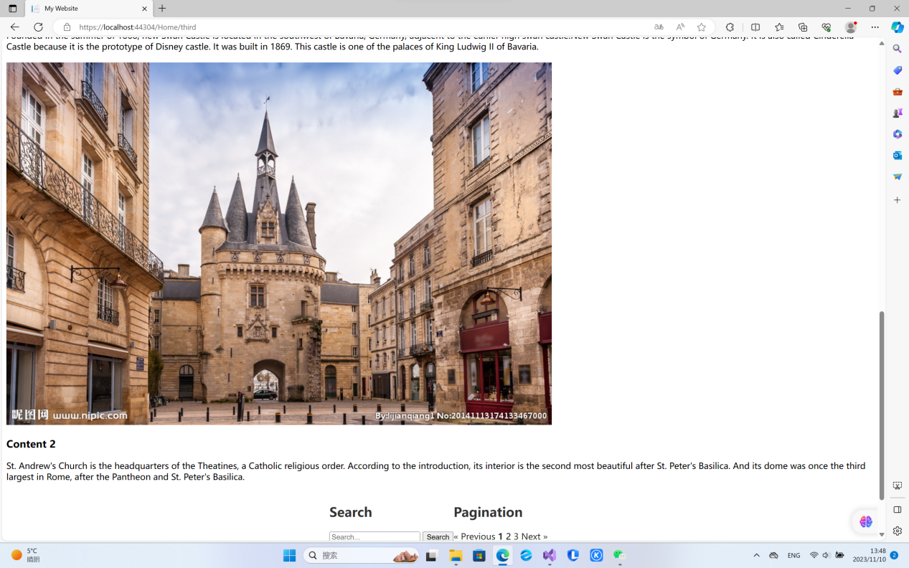dis

**The Tips page** can help you organize and filter the list and suggestions for your trip, and we use the filter function on this interface to help you filter by luggage list, food list, as well as transportation mode and creation time, in the order of the first letters A-Z, Z-A, which will help you travel.

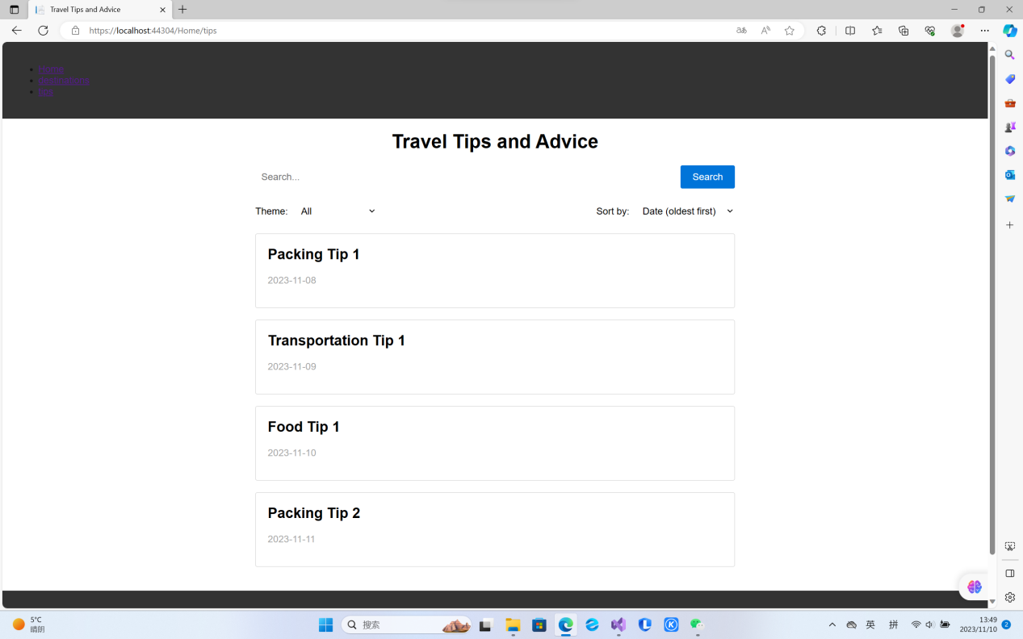

**Utilizing Website Features**:

In order to protect the privacy of your information, if you are a new user, you only need to click the registration button to create your own account, and if you already have an account, you can enter the account password. Click the Home, Destinations, and Tips buttons in the navigation bar of the page to jump to the corresponding interface. On the destinations page, you can enter a number in the search bar below to help you quickly find the page. On the tips page, you can filter what you need.

**Technical Demonstrations：**

1. Models:

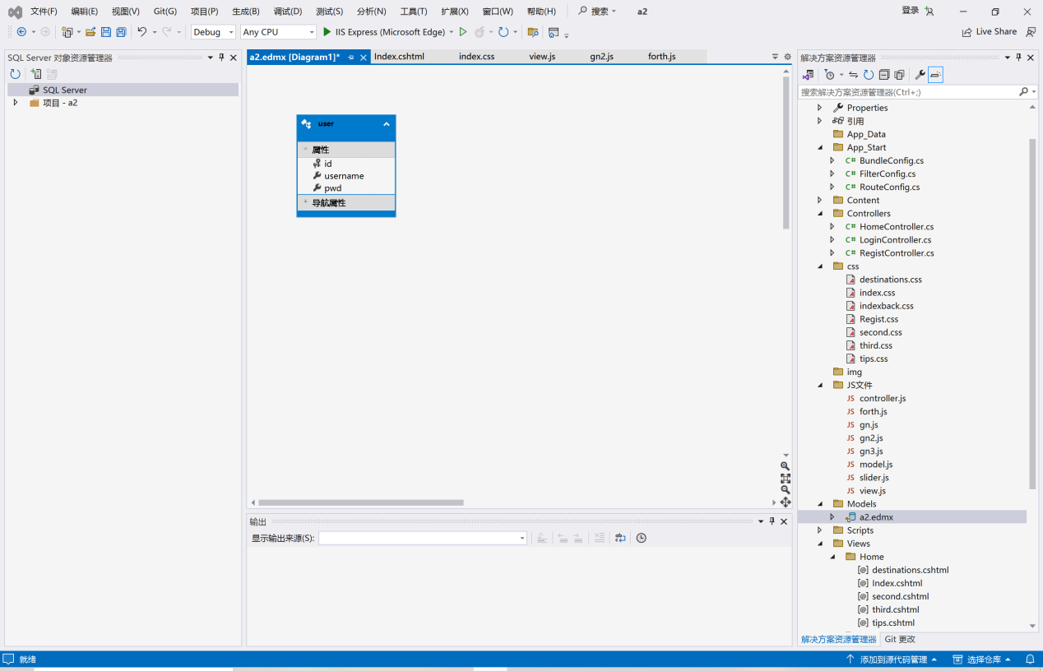2.CSS:

CSS: Cascading Style Sheets (CSS) are used to define the visual style of the website. The CSS code in this website sets properties such as font styles, colors, margins, and padding. It ensures a consistent and visually appealing presentation across different devices and screen sizes. The CSS rules are organized, making it easy to modify the appearance of various elements.

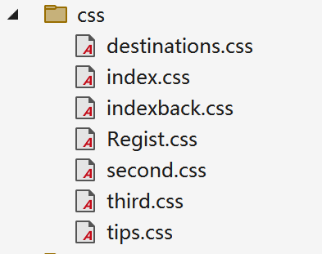

Below is a partial screenshot of the tips page css using

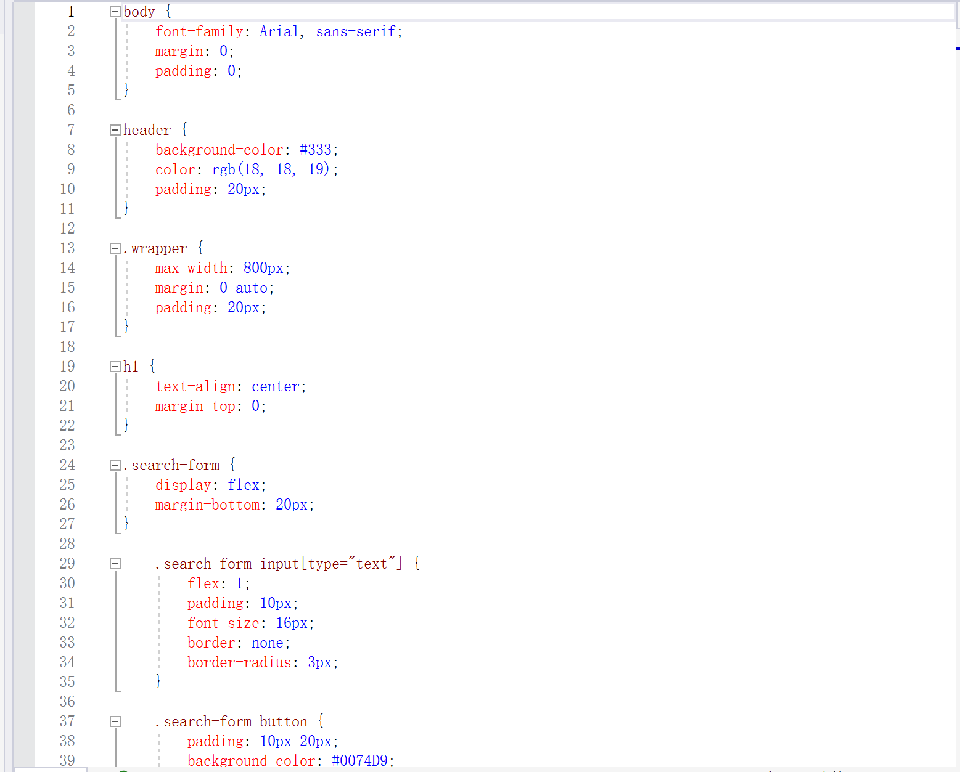3. JavaScript: To implement the search and sorting functionality, the JavaScript code uses a combination of event listeners, conditional statements, and array manipulation.

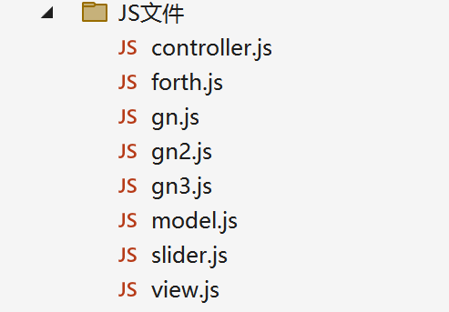

4. Feature Implementation:

**Registe：**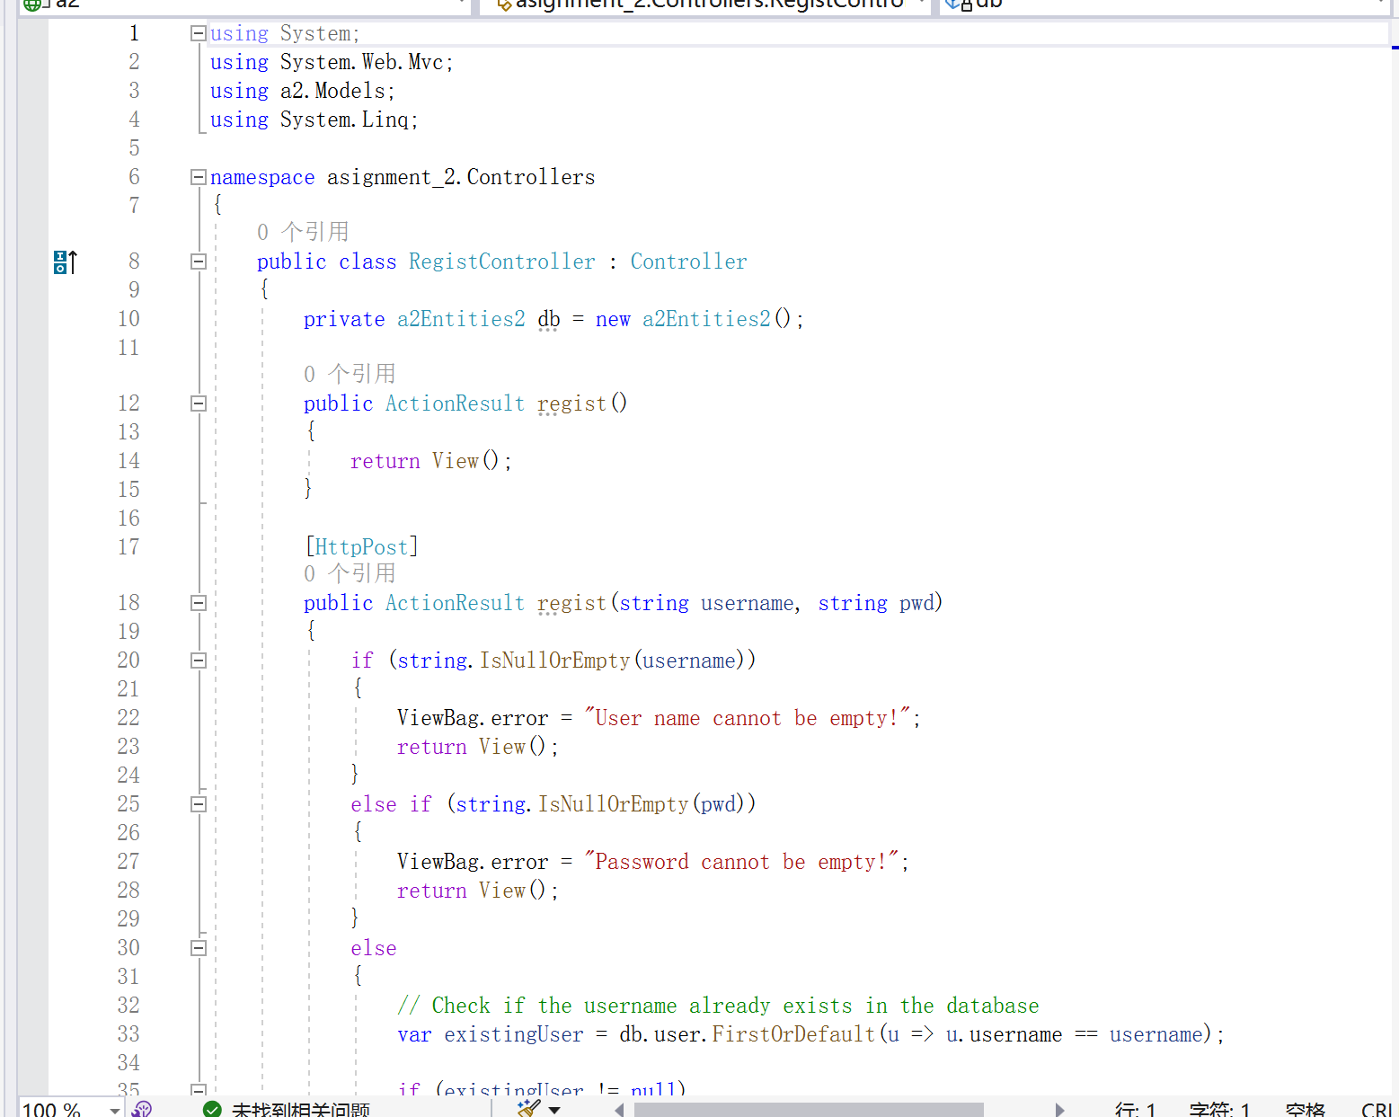

**Search Functionality:** The search functionality is implemented using JavaScript, which listens for user input in the search bar and performs a search operation based on the entered keyword.

To achieve this, an event listener is attached to the search form, which captures the user's input and triggers a search function to run. The search function takes the entered keyword as an input parameter and iterates through all the travel tips displayed on the webpage.

For each tip, it checks if the keyword exists anywhere within the text content of the tip. If a match is found, the corresponding tip is displayed on the page, while those that do not match are hidden using the CSS display property.

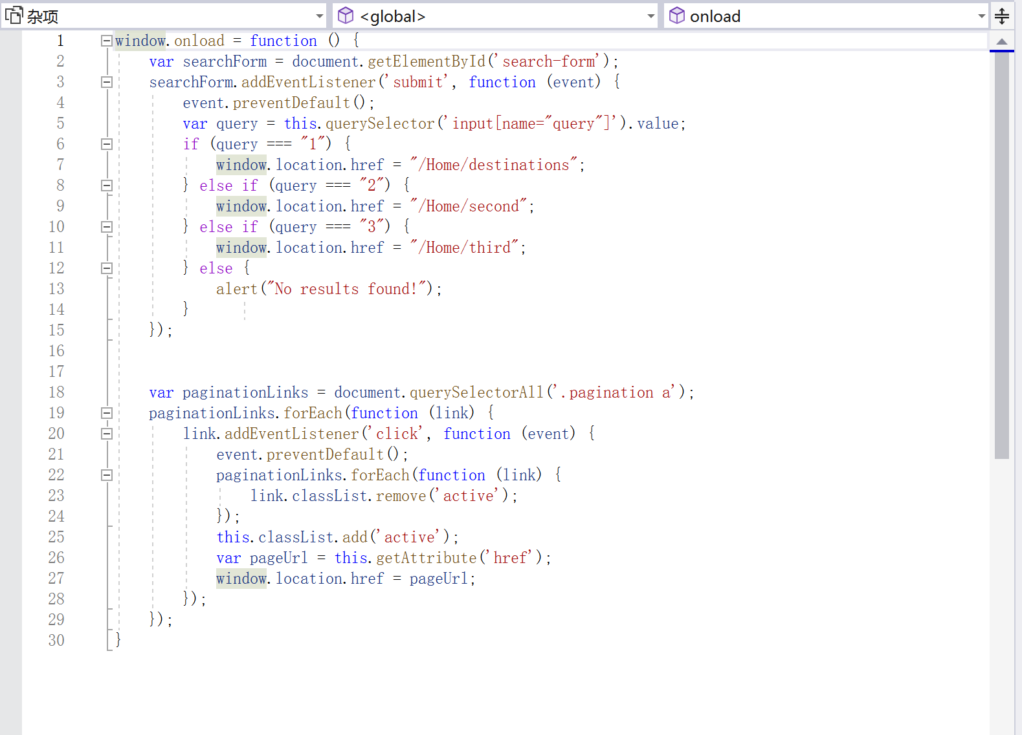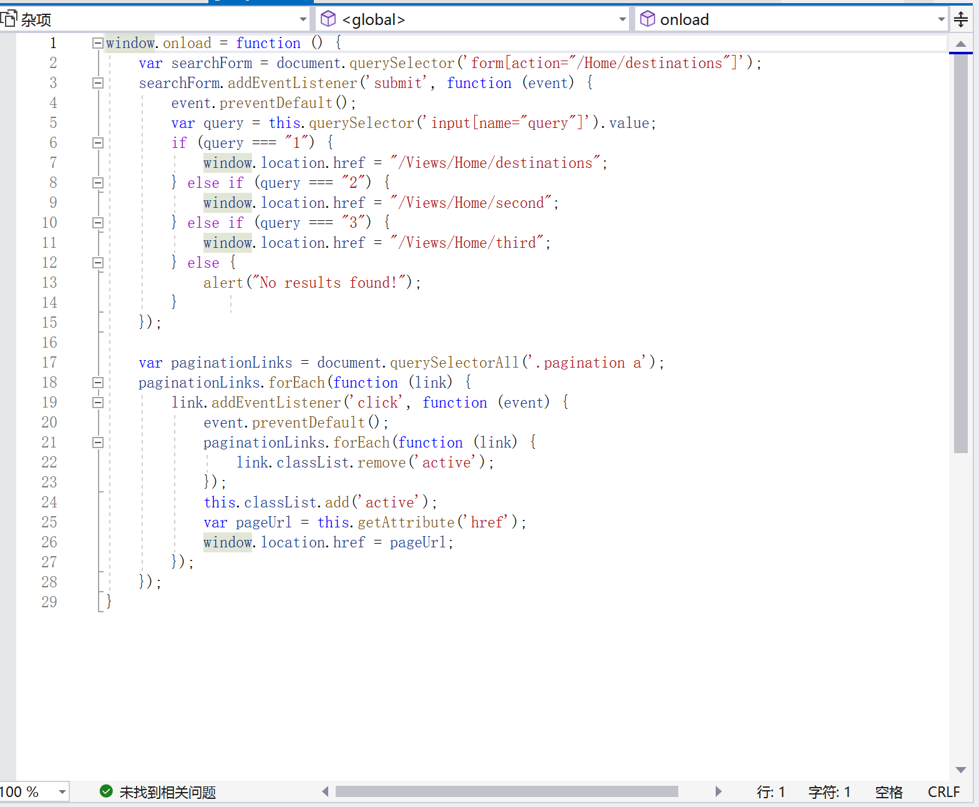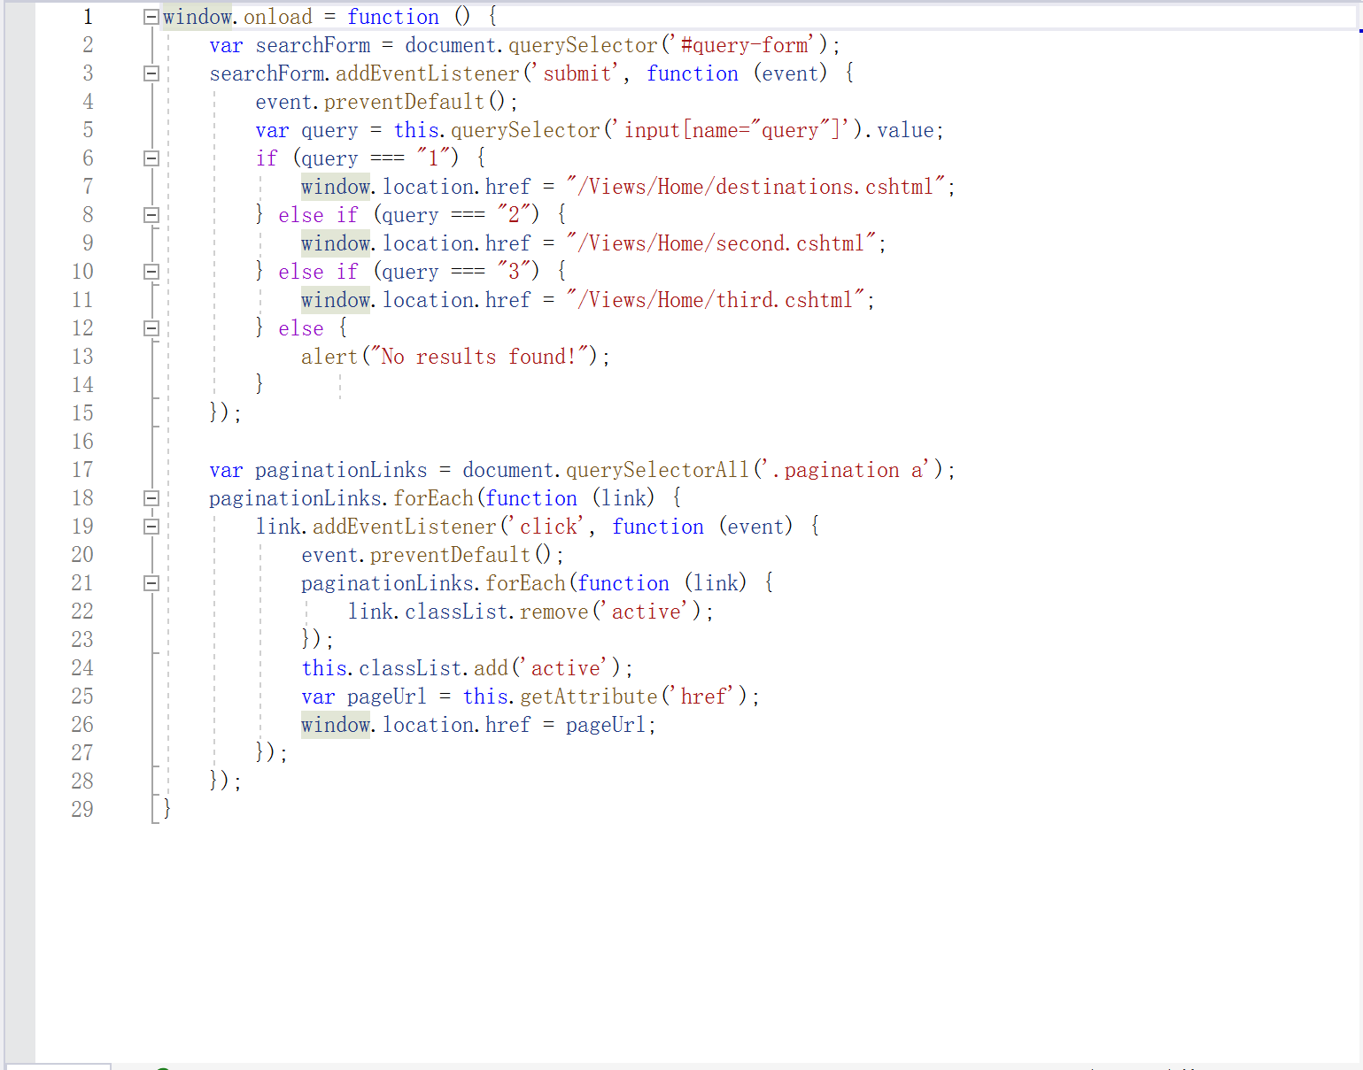**Sorting Functionality:** The sorting functionality is achieved by dynamically reorganizing the displayed tips based on the selected filter options. The JavaScript code listens for changes in the filter options and responds by manipulating the DOM elements accordingly.

When a user selects a filter option such as theme or sort order, the code iterates through each tip item, hides or shows them based on the selected filters, and sorts them based on the chosen criteria.

For instance, if the user selects "beach" as the theme filter, the code will hide all tips that do not contain the word "beach" in any of their content. Once the tips are filtered, the code sorts them based on the chosen criteria.

For example, if the user selects "date added" as the sort order, the code will sort the tips in chronological order based on their creation date, with the most recent tips appearing first. The JavaScript Array.sort() method is used to compare the relevant property of each tip object and reorder them accordingly.

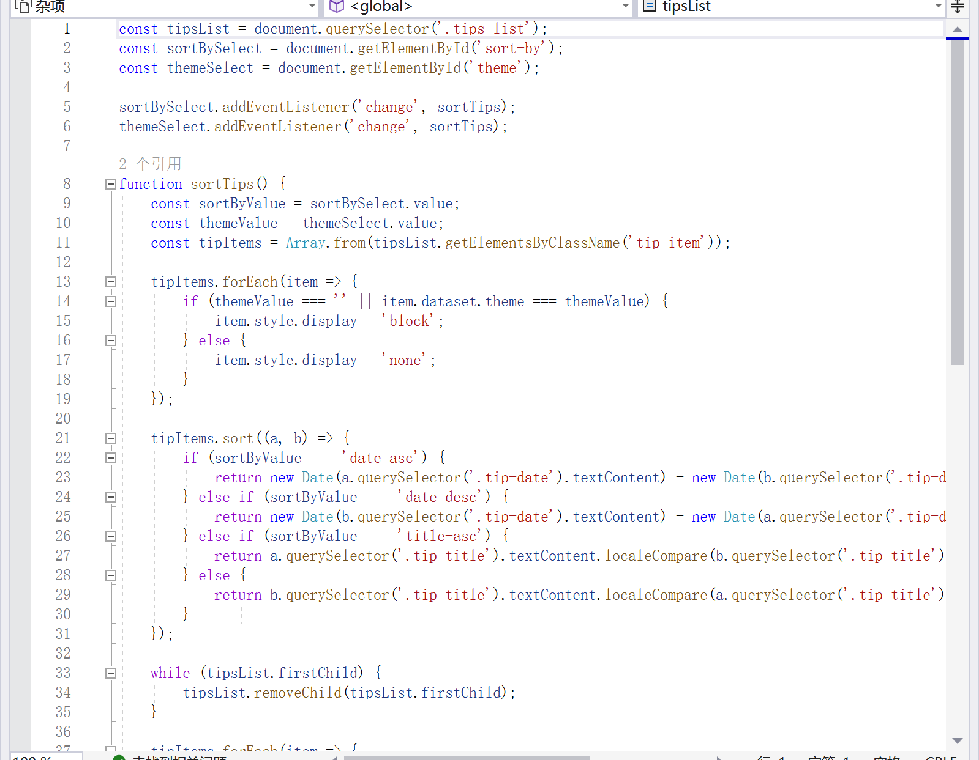**Additional Implementation Details:** To implement the search and sorting functionality, the JavaScript code uses a combination of event listeners, conditional statements, and array manipulation.

The search function uses a for loop to iterate through each tip object, checking if the entered keyword exists in any of the content properties using the JS string method "includes()". If a match is found, the CSS display property is set to "block" to show the tip.

The sorting functionality uses similar logic, iterating through each tip object, checking which filters are selected, and setting the CSS display property to "none" to hide tips that do not match the selected filters. The Array.sort() method is then used to sort the remaining tips based on the chosen criteria.

Overall, the JavaScript code enables a seamless user experience by providing dynamic functionality that allows users to search and sort travel tips based on their preferences.

The website provides an immersive and interactive experience for users looking for travel tips and advice. Technical implementations ensure that the website is visually appealing, responsive, and provides seamless functionality.

Video <https://www.bilibili.com/video/BV1xb4y1g7cZ/?share_source=copy_web&vd_source=62fa3490c54c688bf85b5c52257d744a>